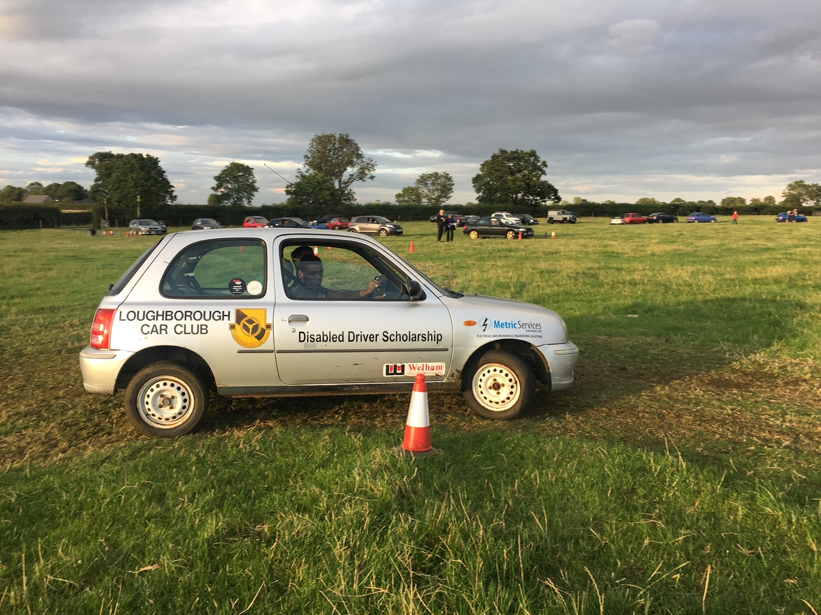
You thought you couldn’t but you can!
Club Motorsport

A competition to select two drivers to take part in a year’s paid for “Club Motorsport”.

CLOSING DATE FOR APPLICATIONS SATURDAY 7th May 2022
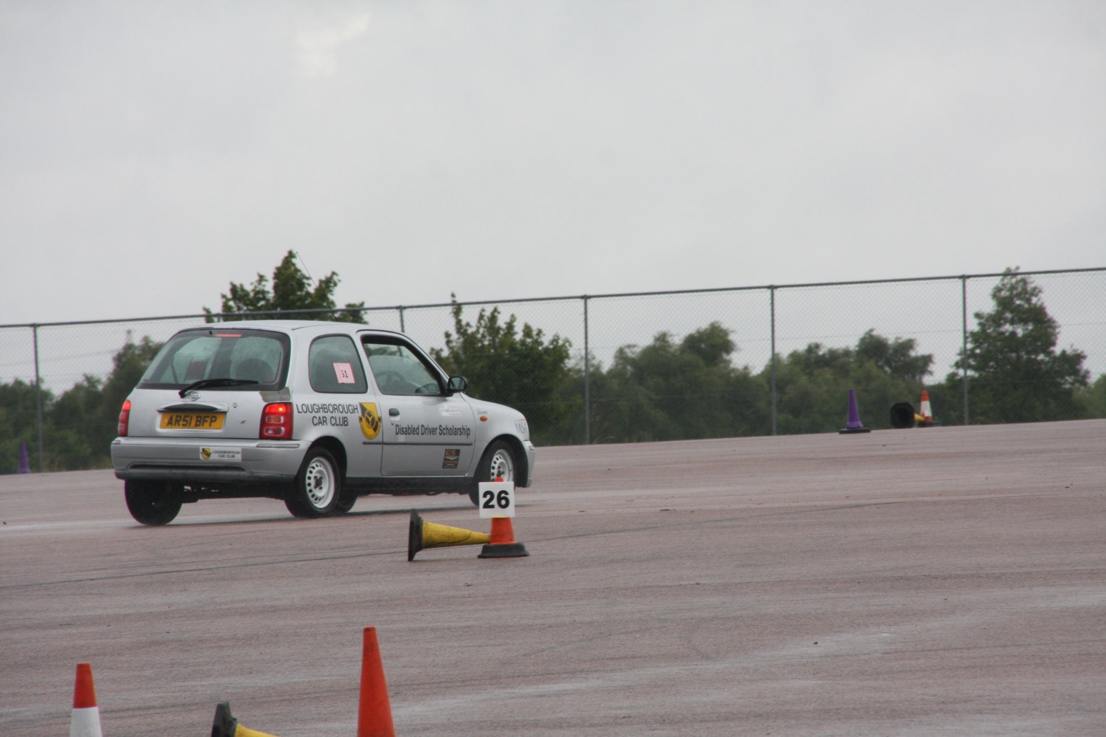
From all the applicants twelve drivers will be invited to attend a selection and training day where their driving aptitude and personal attitude will be assessed. All participants will get to drive a suitable car on a series of tests designed to assess car control (not speed that comes later). The participants will also be assessed on their ‘determination’, ‘competitive approach’ and ‘communication skills’.

From this group - two drivers will then be invited to drive in a series of club AutoSOLO & Autotest events based in the Leicestershire area. All the costs associated with competing will be covered by existing sponsorship.

Outline information

Eligibility
Aged 14 or more.
Able to control a car using common adaptations listed below.
(Steer, stop and drive with reasonable accuracy). Note this does not require a driving licence.

Assessment Day
Safety briefing.
Car acclimatisation and practice.
Driving tests and car control assessment.
Individual interview.
Announcement of successful candidates and award ceremony.

Competitive Events
These are all existing events available to all Loughborough Car Club members. A complementary Motorsport UK Licence and Club membership will be provided.
Seven rounds of the Loughborough Car Club's Tuesday evening Grass Autotest championship.
Loughborough Car Club's all day AutoSOLO which is a round of a nationwide series.
Four rounds of the Donington WinterSeries, a series of Saturday AutoSolos

The Car
A suitably adapted 1400 cc saloon automatic with
a) Hand operated accelerator and brakes
b) A choice of accelerator positions.
c) Additional upper back support to give drivers more stability.
d) A choice of steering wheels with and without a simple spinner.

Costs
All costs including entry fees, maintenance, fuel and tyres provided by the sponsors. Note participants will be expected to arrange their own travel to and from the events.

Support
Experienced club members will be in attendance to advise, mentor and provide mechanical support.
The car will be prepared and maintained by members of Loughborough Car Club.

Important dates for the diary
Saturday or Sunday | One of 20th,21st, 28th or 29th May | Assesment Day
Tuesday Evening | 7th June | Grass Autotest
Tuesday Evening | 21st June | Grass Autotest
Tuesday Evening | 05th July | Grass Autotest
Tuesday Evening | 19th July | Grass Autotest
Tuesday Evening | 2nd August | Grass Autotest
Tuesday Evening | 16th August | Grass Autotest
Tuesday Evening | 30th August | Grass Autotest
Saturday Day | 10th September | Coventry MotoFest AutoSolo
Saturday Day | Late September 2022* | Winterseries AutoSolo
Saturday Day | November 2022* | Winterseries AutoSolo
Saturday Day | January 2023* | Winterseries AutoSolo
Saturday Day | February 2023* | Winterseries AutoSolo
*These dates cannot be confirmed until mid 2022
To obtain an application form contact scholarship@loughboroughcarclub.co.uk or phone 07971 596551

Background

There are several popular misconceptions about motorsport of which the most common are that it is very expensive, and not easily accessible. In truth motorsport exists at all sorts of levels and much is considerably more accessible than many believe. There are many branches of motorsport that do not require a highly specialised vehicle.

So why the Scholarship project? The background is that the club got invited to become involved with the formation of a motor club exclusively for disabled competitors. This failed when it soon became apparent that there are a number of disabled competitors already competing at a variety of levels, and those who do compete are adamant that there is no demand for a separate branch of motorsport. The overriding view was that motorsport is an activity where there is no need for a separate division. The range of disabilities that can compete turns out to be quite broad.

So is it a suitable sport for a disabled person? Possibly yes. The key point in this context is that the bulk of performance comes from the mind, and given that a driver has reasonable control of a car, motorsport is accessible. Which gives rise to the question, why are there not more competitors. The general answer seems to be lack of awareness.

And so, the scholarship project was conceived in 2008 to demonstrate that many disabilities are not a bar to participating in club motorsport. And to establish that the costs are not prohibitive.

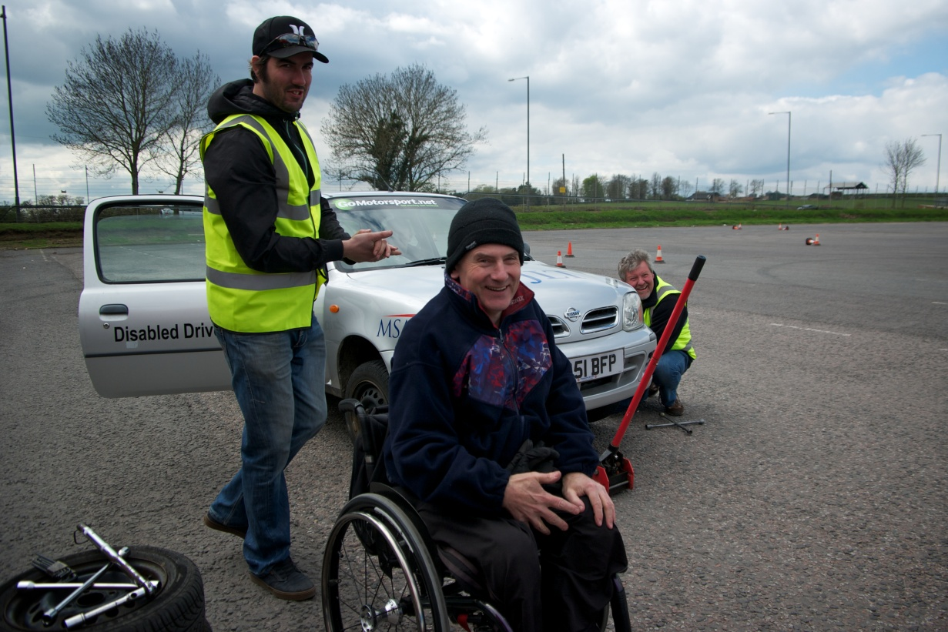

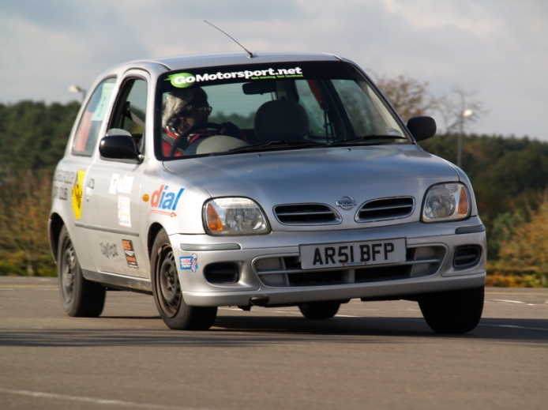
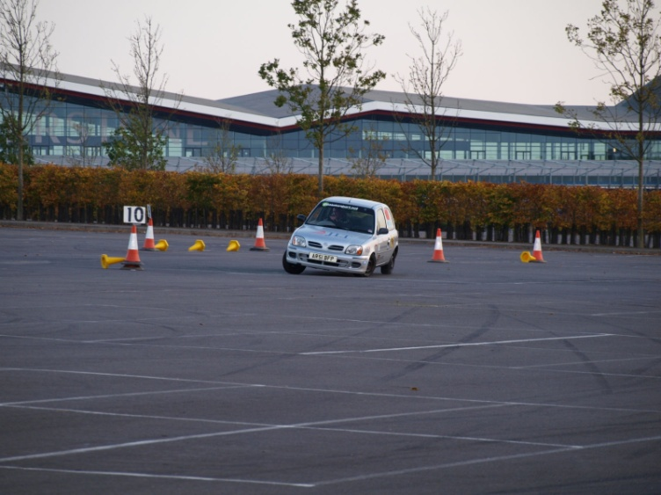

Partners
Loughborough Car Club: - A district car club notionally centred in Loughborough
but with a membership drawn from a 50 mile radius. Specialising in the promotion of club level motorsport, and the induction of new competitors and officials to motorsport.

Motorsport UK: - the governing body of motorsport in the UK. Providing both financial support and enthusiasm.

MW Vehicle Contracts:- Financial & Marketing Support
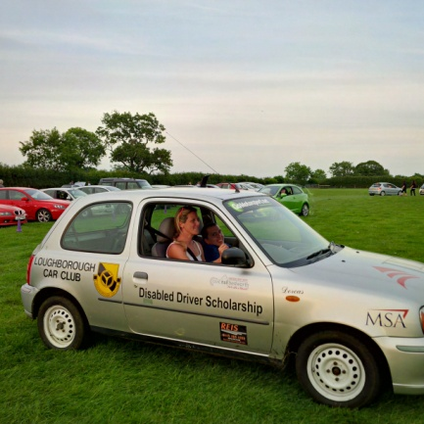
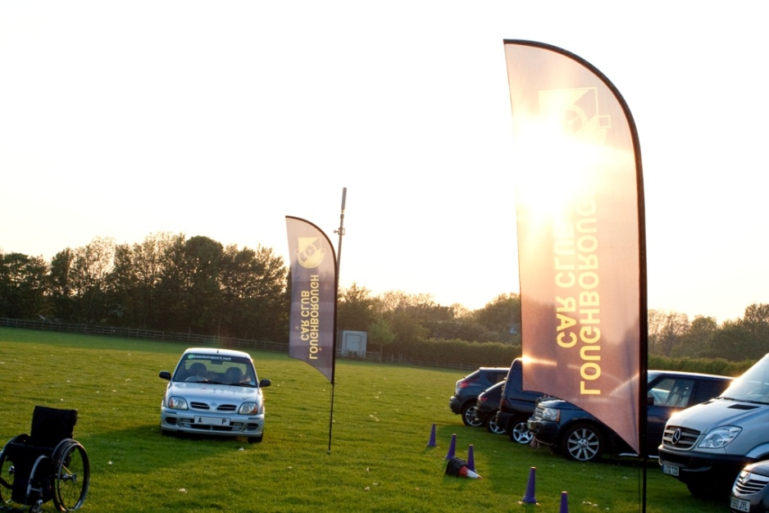

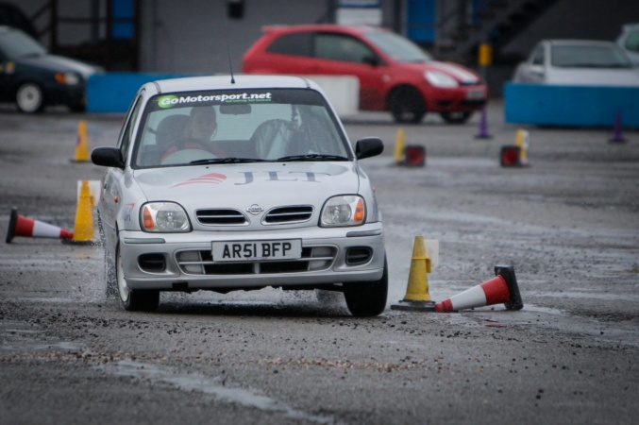

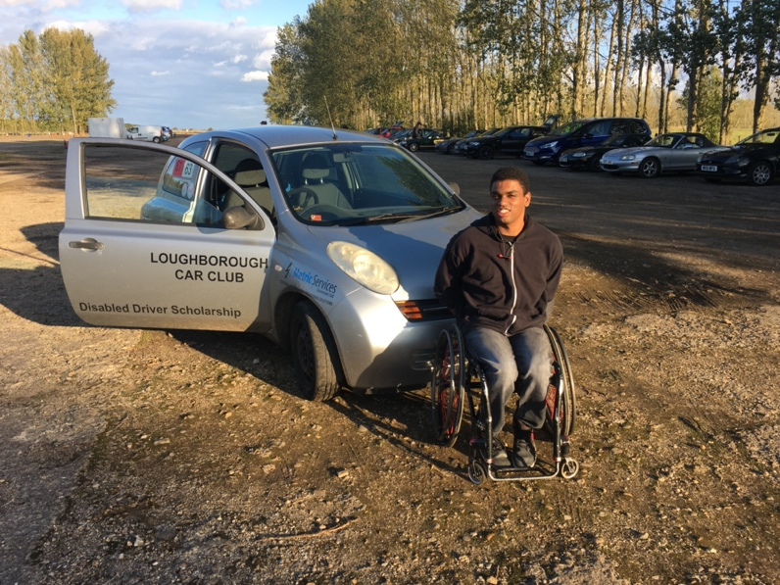

THIS COULD BE YOU

